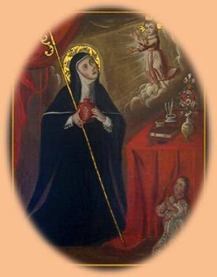

Welcome to our
Apostolate of Purgatory!

St. Gertrude
Please send a confirmation e-mail to me at mike.hump@comcast.net when you have received this package. Otherwise I will not know if you received it or not. Thanks!!
My mother, Dorothy Humphrey passed away to her particular judgment on January 31, 2011 and my Father in May of 2007. Because the Lord has not provided me with any full-time work where I can support this apostolate, any financially help you could provide to continue this work would be appreciated. At least one of our FREE Purgatory Prayer Program starter kits has been sent to 37 out of the 50 United States.
If you like the idea behind this program and wish to either:
- Support it for others interested in starting Purgatory Prayer Programs for the Holy Souls, or
- just help pay for the postage and shipping,
it would be appreciated. You can donate at: http://www.helpersoftheholysouls.com/donate
Via PayPal or using Brian’s postal address.
Thanks for your interest. Let’s keep in touch!
Mike Humphrey and Brian Bagley
P.S. Remember to contact me if you change your e-mail address.
I can’t provide updates to you and new ideas if we don’t keep in touch.
Feedback and suggestions are always appreciated.
You can send your feedback to Mike Humphrey @ mike.hump@comcast.net.

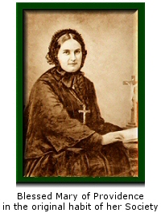
Welcome to our
Apostolate of Purgatory!

Dear Purgatory Prayer Warrior,
Both Brian and I would like to welcome you to our Helpers of the Holy Souls Prayer Program!
We think the work of praying for the Holy Souls in Purgatory has been overlooked for way too long. As stated on our home page HelpersOfTheHolySouls.com:
Helper of the Holy Souls is inspired by Blessed Mary of Providence and the original mission of the Order she founded in 1856, Society of Helpers of the Holy Souls.
Our mission, one of mercy, is to relieve and gain release for the suffering souls in Purgatory who can no longer help themselves.
Enclosed you will find both a paper and computer version of our prayer program in English. The enclosed CD also has the program in six other foreign languages as well: Spanish, Portuguese, French, Italian, German, and Polish. If you are disappointed with any translation and wish to help provide a better one, e-mail me.
You can use the CD versions of the program to create Purgatory Prayer Programs in other languages using the attached set of Purgatory Prayer Program Supplies Sheets.
Though the outline of the program can be found on the Suggested Holy Hour Order of Prayer card, you are more then welcome to change any portion of it according to your time, desires, and interests and make it YOUR Purgatory Prayer Program for the Holy Souls.
The Program was designed to be an autonomous one; one that, God-willing, will be perpetuated to your friends, family, parish, diocese, and beyond. As I said, the needed supplies for this Purgatory Prayer program can be found in the attached supply sheets. The vision of this program was not to receive feedback like: “Can we have ## more packages?”
We encourage you to work as a group to customize, reproduce, and buy the supplies required to replicate this Prayer Program using the information in the attached set of Supply sheets.

The disc [CD], itself, is a RW or Read Write CD. This will allow you to add your updated, personalized version of your own Purgatory Prayer Program. We recommend that you initially move ALL the contents of the current CD to your [PC | hard drive], then move ALL the contents back to the CD in addition with your personalized updated version(s). You can create separate folders for each, like: [Original] and [Personalized May 20##] There should be plenty of remaining CD space for the original program content along with your personalized versions. Check out the benefits of a “at home” prayer program at:
http://www.helpersoftheholysouls.com/waystohelp/StartYourOwnPrayerProgram.htm
We have found that some participants have initially started our program as a private prayer devotional, before bringing it to their pastor for a possible regular prayer program within their parish. For Deacons and Priests who have asked for a program, we suggest talking to their bishop about offering this, or a similar program, at a diocesan level.
When talking with friends and family on Purgatory, it’s important they know the basics:
- Purgatory is not a third place along with Heaven and Hell nor is it a second chance.
- Purgatory is like the Holy Hospital of Heaven.
- Souls in Purgatory have been saved just as much as the souls in Heaven.
Think of sin as a self-inflicted wound in your life.
When we physically hurt ourselves, many times we have to be brought to the hospital and the doctor or nurse will put an alcoholic disinfectant in our cut or wound. It will hurt ... a lot!!! but it's a good hurt; it's a holy hurt, that is needed to make us physically better.
We also have to distinguish between less severe physical injures where we cut ourselves and require stitches and more severe injures, like a NASCAR racing driver who gets into a major collision and ends up with third or fourth-degree burns over 90 percent of their body. There are varying degrees of damage that we do to our bodies, not only physically, but spiritually too!
Because Revelation tells us that nothing impure can enter Heaven (Revelation 21:27) and because God Himself is all Holy, we too, have to be all Holy to enter Heaven. To achieve this, any remaining
self-inflicted spiritual wounds or self-love from our pilgrimage on earth has to be healed or burned off. If our spiritual injures are along the line of “just needing stitches”, that healing period where our
self-love has to be burned off may be short; but if our self-inflicted injuries are along the line of third
or fourth-degree burns, the healing process may take longer. Saints have had private revelations from the souls in Purgatory who share that while the [healing | burning] fires of God’s Love in Purgatory are painful (Hebrews 12:29, Exodus 3:1-6) at the same time they had an internal burning joy because they knew they were being conformed to the image of God and their final destiny would be total union with Him.
Instead of the good healing pain that the alcoholic disinfectant gave us under a doctor’s care to prepare us to re-enter the earthly world again, in Purgatory, we experience a holy, healing pain under Jesus’ Care which purifies our souls and prepares us to enter eternal life with God who is all Holy. Think of the number of people who have passed from this life to the next since 33 A.D., many with major spiritual injuries. There are a lot! This is why praying for the Holy Souls in Purgatory is very important – and they can’t wait for Heaven!
Keep in touch with me via e-mail and most importantly e-mail your new e-mail address, if you change your e-mail address.

Mike @ mike.hump@comcast.net
Ways to help the
Holy Souls in Purgatory!
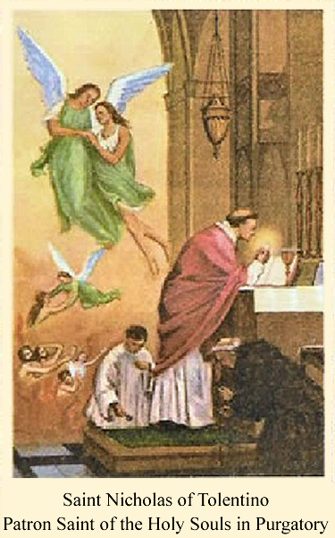

14 Ways to help the Holy Souls in Purgatory

- The best way to help is to have the Holy Sacrifice of the Mass offered up for them ¹ or devoutly assist at Holy Mass for their relief.
- Make the Stations of the Cross for their consolation.
- Pray the Holy Rosary of the Blessed Virgin Mary for them.
- Gain indulgences for them ²
- Offer up pains, self-denials and sufferings for their relief.
- Pray, offer up works of mercy and practice virtues for their consolation.
- Ask the Blessed Mother to choose an unknown soul for you to pray for.³
- Lovingly sprinkle Holy Water, in faith and with trust, for their cleansing.
- Light their darkness, as an act of love, by burning a blessed candle for them.
- Liturgical prayers like:
  - De Produnis (Psalm 129 {Official prayer for the Holy Souls in Purgatory} , found in most Catholic prayer books.)
  - Pray the Office of the Dead or Vespers, the liturgical hours of the Church.
  - "Eternal Rest" prayer:
Eternal Rest grant unto them O Lord and let perpetual live shine on them and may the souls and all the souls of the faithfully departed rest in peace.
  - Prayers from the Roman Missal for the Souls in Purgatory.
- Visit a Church or Chapel and spend some time in front of the Blessed Sacrament for their comfort and relief.
- Visit a Cemetery, and pick out a number of grave stones and say some prayers for their souls.
(From November 1st - 8th, a plenary indulgence can be obtained for the departed souls by devoutly visiting a cemetery and praying for the dead. Use the tombstone as a kneeler and pray the Rosary for your loved one.)
- START YOUR OWN PURGATORY PRAYER PROGRAM TODAY!
See the last paragraph of this handout!
- Organize collections for Masses for the Holy Souls. Check out how we have organized our Masses for the Holy Souls Program in the next section.
1 All monthly donations to Helpers of the Holy Souls go to having Holy Masses offered up for the relief or deliverance of souls in Purgatory.
2 Catechism of the Catholic Church 1471-1479. The Handbook of Indulgences also may be consulted.
3 e.g, Rosaries, rosary decades, Stations of the Cross, special prayers, any merciful acts, etc.

Having Masses said for the Holy Souls.

Before explaining our organization and approach to having Masses said for the Holy Souls, let’s clarify some terms and possible issues people may have.

In training his disciples on bringing the Gospel to the world, Our Lord told his disciples in Luke's Gospel:

Go your way; behold, I send you out as lambs in the midst of wolves. Carry no purse, no bag, no sandals; and salute no one on the road. Whatever house you enter, first say, 'Peace be to this house!' And if a son of peace is there, your peace shall rest upon him; but if not, it shall return to you. And remain in the same house, eating and drinking what they provide, for the laborer deserves his wages; do not go from house to house. Whenever you enter a town and they receive you, eat what is set before you; heal the sick in it and say to them, 'The kingdom of God has come near to you.'

Luke 10:3-9

From this we clearly see that Our Lord believes in a just wage for the work of His new priests/disciples. The word the Church uses today for this is called a stipend. A stipend is a fixed pay, salary or retribution for work done; the income of an ecclesiastical living.

In order to have Masses offered up for the Holy Souls on a regular basis, we collect stipend money on a monthly basis. Is it something that's required? <No.> Is it something that is just? <Yes.> This allows us to have Masses said by priests who value this important, but sometimes overlooked, intention of the Universal Church. Stipend amounts for a Mass intention vary from parish to parish. Any objections to stipends as a money making machine can quickly be diffused as no priest is going to get rich over Mass stipends. In the Boston area, the suggested amount for a Mass stipend is usually about $10.00.

There are three (3) sources Brian uses to collect stipend money for our Mass intentions:
- He gathers empty cans and bottles from friends and family, who have no interest or use for them and redeems them at a local supermarket for cash.
- He gathers individual donations in multiples of $10.00 from friends and family who wish to have a Mass said for the Holy Souls.
- Finally, he gather "pocket change" from anyone one who can't afford to make a $10.00 donation. We call this part of our program "Pennies from Heaven."
During the calendar year, at most parishes, Mass is offered up for a particular intention on various days.
Brian calls or stops by the rectory to find out what Masses he can have scheduled to be said for the Holy Souls in Purgatory. How far in advance we can schedule a Mass will vary from parish to parish. An important key to doing this successfully is developing a good relationship with the personnel at the rectory.

Most of the time, stipend money collected in one month, is used to schedule Masses for the Holy Souls for the next month. What you can and can't do will vary from parish to parish and diocese to diocese.

Brian has a very organized method for keeping track of Masses he has scheduled.

As a means of organizing his efforts, he uses:
- a metal cash or security box
- a deposit bag — most retail stores use to bring their revenues to the bank
- a 8.5" x 11" yearly organizer (e.g. Day Minder, At-A-Glance) and
- a contact book
The metal cash or security box and deposit box are used to secure donations made by friends and family as well money collected from his empty bottles and cans program.

The yearly planner he uses can be bought at any Staples or Office Max. He uses this to keep track of the Masses he schedules at the various parishes.

His contact book keeps the names and postal addresses of Churches he has worked with along with phone number and contact names of the people he talked to.

It's our hope that sharing the way Brian has organized his apostolate will assist you in starting and developing your own.

Start Your Own Purgatory Prayer Program Today!
At Helpers of the Holy Souls, we offer a FREE start-up Purgatory Prayer Program that you can customize to your liking. It can be said as a private devotional in a chapel or church or be said as a monthly Catholic prayer meeting in a chapel, church, or even at someone's home.
I was involved in a monthly First Saturday prayer meeting for at least eight to ten years at a friend's home.
Monthly Catholic Prayer Meetings are a great way to:
- pray for the Church Suffering as well as strengthening the Church Militant
- confirm fellow Catholics in areas of the faith they may have questions about.
- share common struggles and sufferings (as well as joys and successes) on home and work-related issues
- meet new friends and connect with old acquaintances.

Usually after the prayer meeting, my friend's wife was gracious enough to have some coffee, soda and other snacks prepared.

HelpersOfTheHolySouls.com supports these types of Catholic prayer meetings as long as "the talk" before and after the prayer meeting is faithful to the Church.
Many times, conversation about unapproved Marian apparitions can arise or a "Gnostic environment" can develop:

e.g. "You are so privileged to know this information that the rest of the Church doesn't know."

If conversation or practices develop within the prayer meetings that are contrary to ANY paragraph of the Catechism of the Catholic Church or Church's Magisterium, you know it's time to leave. Prudence should be used in discerning whether the issues involved should be brought to the local bishop.
Purgatory Prayer Program Supplies Sheets
The following sheets give you the needed information so you can order more supplies for your Purgatory Prayer Program.

The only items in the Prayer Program that were custom-made by Helpers of the Holy Souls were the Holy Cards. We can send you a limited supply for each. Just send a request to the listed e-mail along with the postal address for the Purgatory Prayer Program.

Staples® or similar Card Stock,  8 1/2" x 11", White, 250/Pack  Eye-catching, soft pastel colors!  - 110 Lb.  - 8 1/2" x 11"  - White, 92 bright  Item 490887  Model 49701  You can use this or a similar product to replicate most of the Prayer Program in the packet.  If you don’t have a “Paper store” where you live, you can write out the Prayer Program on any similar sheet of paper. Any nearby printer or Office store can cut the sheets as needed. |   $9.98 250/Pack
L15 Leaflet  3 places to order:  USA:  Divine Mercy Publications  P.O. Box 26531  Tamarac, Florida 33321  Web site:  Telephone: (954)-927-9057  ----------------------------  Canada:  http://www.divinemercydistribution.com  No e-commerce on this site.  They do take MC and Visa  Divine Mercy Publications  R.R. #4 Lanark, Ontario KOG 1KO, Canada  Telephone: (613)-259-9113  Price = $0.35  50 for $16.50  100 for $30.00 | 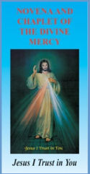
Dublin, Ireland
http://www.divinemercy.org/

Novena and Chaplet to the Divine Mercy
10 for $3.00
50 for $8.50
100 for $12.50
1000 for $115.00
€28.63

Shipping and handling for 100 is $18.55
Monastery of the Precious Blood  5400 Fort Hamilton Parkway  Brooklyn, New York 11219-4037  (718) 438-6371 - Fax: 438-6381  http://www.sisterspreciousblood.org/  -----------------------------------------------  5.25” X 3.5” 2 page folder out  Novena to the Precious Blood  Sister Margaret Mary  Call and we will send them to you. | 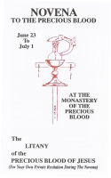
Our Lady of the Rosary Library  11721 Hidden Creek Rd.  Prospect, KY 40059  Phone (502) 425-9738  http://olrl.org/library/oform.shtml  ---------------------------------------------  Litany for the Poor Souls in Purgatory  3.33” X 5.5” | 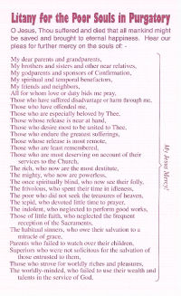
  Litany for the Poor Souls in Purgatory | 2¢ ea.
Item: L01  © Holy Face Association  P.O. Box 1000, Station A,  Montreal, Quebec, Canada H3C 2W9  P.O. Box 821,  Champlain, New York, USA 12919-0821  Telephone: (514) 747-0357,  Fax: (514) 747-9147  Date last modified: Sept 6, 2005  http://www.holyface.org  Holy Face Golden Arrow  Holy Face of Jesus 3 page pamphlet - explanation  Enter our site > On-line Store > Leaflets  100 for $3.00  1000 for $30.00 | 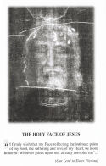
Number: 14/05  The Fourteen Stations of the Way of the Cross with Meditations  By St. Alphonsus Liguori  Catholic Book Publishing Co.  77 West End Rd.  Totowa, NJ 07512  Monday–Friday, 8:45 a.m.–5:00 p.m. East Coast time.  Telephone: 973-890-2400 #7  E-mail: info@catholicbookpublishing.com  http://www.catholicbookpublishing.com/  Product Code: 14/05  ISBN: 0-89942-014-1  No. of Pages: 32 Size: 3 7/8 X 6 1/4  Color: ILLUSTRATED, Cover: PAPERBACK  PAULINE BOOKS & MEDIA,  885 PROVIDENCE HWY, RTE. 1  DEDHAM, MA 02026  781-326-5385  Catholic Book Publishing Co.  Cannot sell to you. Have to be a Catholic bookstore customer or church. | 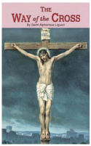
Pauline Book and Media
0.75 each no matter what quantity
Shipping and handling not included.
http://www.catholicbookpublishing.com/products/389
TAN Books and Publishers, Inc.  P.O. Box 424  Rockford, Illinois 61105  Toll Free: (800) 437-5876  Direct: (815) 226-7777  Fax: (815) 226-7770  Email: customerservice@tanbooks.com  https://www.tanbooks.com/index.php/page/shop:prayercards/  -----------------------------------------------  How To Gain a Plenary Indulgence  100-400 - $7.50/100  500-900 - $5.00/100  1000-9,999 - $3.50/100  10,000 - $3.00/100 | 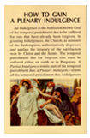
Pat Balderrama  St. Michael's Store  (909)829-1328  All Souls Novena  10 - $0.80/ea  100 - $0.65/ea  500 - $0.55/ea  1,000 - $0.35/ea | 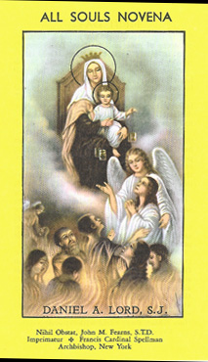
Missionaries of the Sacred Heart  305 South Lake Street  P.O. Box 270  Aurora, Illinois  60507-0270  Telephone: 630-892-2371  Extension 25  Ask for Kathy  http://www.misacor-usa.org/index.php/bookstore#booklets  ---------------------------  Daily Pilgrimage to Purgatory  All booklets are $2.00 each  Shipping and handling included in the price. | 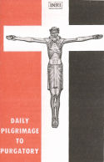
Prayer for the Forgotten Ones  Wholesaler: T. J. Peters Co. Prayer Cards  T. J. Peters Number: TJP 842  Retailer:  St. Andrew’s Book, Gift & Church Supply  305 West 8th Ave  Vancouver, BC, V5Y 1N6  Canada  Phone: 604-875-1441  Toll-free: 1-800-663-7161  Sold per 100. Boxed. $20.00  2-1/2" x 4-1/4" approximate size.  Please contact us for quantity discounts. | 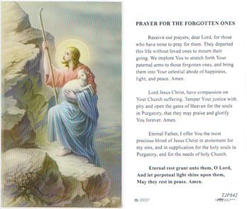
Prayer for the Souls in Purgatory  Wholesaler: T. J. Peters Co. Prayer Cards  T. J. Peters Number: TJP 731  Retailer:  St. Andrew’s Book, Gift & Church Supply  305 West 8th Ave  Vancouver, BC, V5Y 1N6  Canada  Phone: 604-875-1441  Toll-free: 1-800-663-7161  Sold per 100. Boxed. $20.00  2-1/2" x 4-1/4" approximate size.  Please contact us for quantity discounts. | 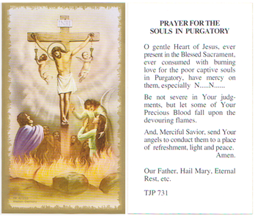
Blessed Mary of Providence  Holy Card  If you are interested in obtaining more of these holy cards, you should be able to create them with the help of a computer person or someone with a print background.  For all three Holy Cards and our Commitment Card, there is a corresponding folder in the CD under the “final printed copy” folder. | 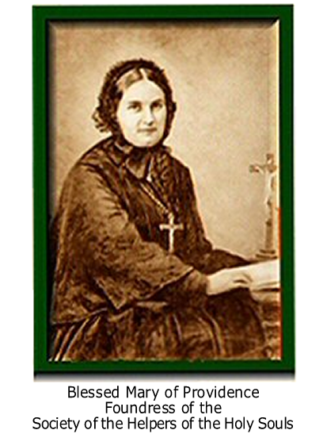
Saint Nicholas of Tolentino
Holy Card

If you are interested in obtaining more of these holy cards, you should be able to create them with the help of a computer person or someone with a print background.

For all three Holy Cards and our Commitment Card, there is a corresponding folder in the CD under the “final printed copy” folder.

Our Lady Queen of Purgatory  Holy Card  If you are interested in obtaining more of these holy cards, you should be able to create them with the help of a computer person or someone with a print background.  For all three Holy Cards and our Commitment Card, there is a corresponding folder in the CD under the “final printed copy” folder. |  | 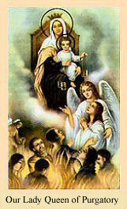
Helpers of the Holy Souls Commitment Card  If you are interested in obtaining more of these holy cards, you should be able to create them with the help of a computer person or someone with a print background.  For all three Holy Cards and our Commitment Card, there is a corresponding folder in the CD under the “final printed copy” folder. | 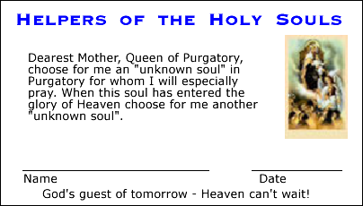
Pray for the Poor Souls in Purgatory Prayer Novena (Prefaced by a comment by St. Thomas Aquinas and St. Augustine on the other side)  http://www.poorsoulsprayers.com  Ron Gurba Jr.  P.O. Box 1  Harvey, Louisiana  70059  You can order them here:  http://www.poorsoulsprayers.com/order.html  50 — $7.00  100 — $9.00  200 — $16.00  300 — $20.00  400 — $25.00  500 — $30.00  100 — $50.00  All booklets are $2.00 each  Shipping and handling not included | IMPORTANT: Stipulation by Archdiocese of New Orleans Archbishop Alfred Hughes: "You must get pastor approval to put your Poor Souls Prayer Cards in any Catholic Church."  Please ask your pastor first, and also ask him if he knows of other priests who would love some cards.
An Optional substitute for The Fourteen Stations of the Way of the Cross with Meditations By St. Alphonsus Liguori  The Way of the Cross for the Holy Souls in Purgatory By Susan Tassone  Recall, reflect, remember, and pray.  Recall loved ones who have died and, in a spirit of true charity, keep in mind other departed souls who may have no one on earth to pray for them.  Reflect on the reality of Purgatory and those who, though so close to Heaven, must still prepare to enter it. These souls, the Church teaches, can benefit from your prayers for them, and their prayers, in return, can benefit you. | From Our Sunday Visitor: https://catalog.osv.com/  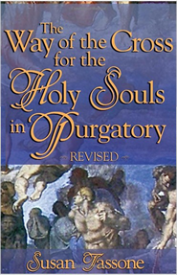  https://catalog.osv.com/Catalog.aspx?ProductCode=411

